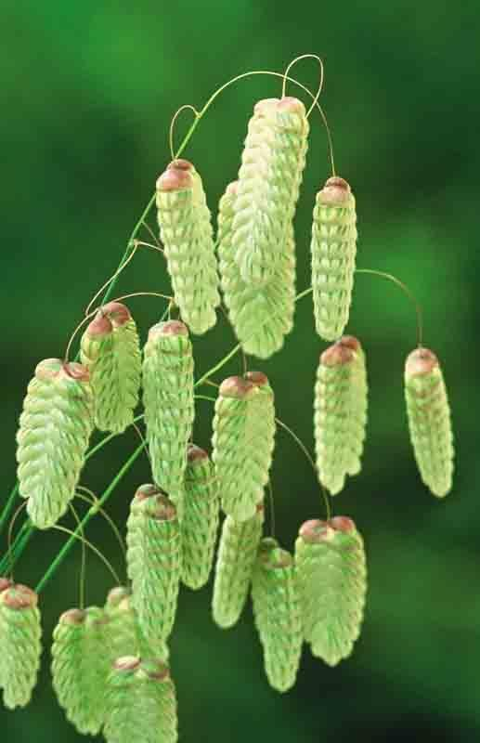

**August Rota**

6th

Leading: Margaret

Communion: Robbie

Worship: Craig

Speaking: Alan

13th

Leading: Robbie

Worship: John

Speaking: Vivianne

20th

Leading: Robert T

Worship: Craig

Speaking: Tom

27th

Leading: Ewan

Worship: Vivianne

Speaking: Alan

**Youth Outings**

A great big thank you to Graeme and Claire for organising 4 days of fun activities for the youth. Judging by the photos they had a great time together. Thanks also to the other helpers who gave up their time to support these outings. It is so good to build wonderful memories of fellowship together for our young people.

~~~~~~~~~~~~~~~~~~~~~~~~~~~~

Graeme and Claire are trying to arrange a day out for the youth to Troon. Unfortunately, the weather changed the plans and they are now looking to arrange a date in August. This could be a good opportunity for the fellowship to join in and enjoy this time together. We will keep you posted on a new date.

**Good News Café**

Sunday, 30th July saw our first evening service take place. This will now be a regular feature on the last Sunday each month. Please take the opportunity to make it known and it would be good to see your support in this new outreach.

Cornerstone Christian Fellowship

Newsletter – August 2023



The poem below was inspired by a dream:

**MY DREAM**

I’m waiting for Him to free me,

Waiting for Him to free me,

Waiting for Him to pass my way,

Waiting for Him to free me.

I’m waiting for Him, to change my ways,

Waiting to live much better days,

Praying for Him to show me the way,

Hoping things lead to a better day.

If there’s no hope, for someone like me,

To change my ways, and another one be,

Or am I trapped to a person like me,

Lord, show me the way, that I can be free,

They say that He is, The Way, The Truth and The Life,

To save me from all my trouble and strife,

Friend, tell me that you will lend me a hand,

To my humble efforts, and understand.

The loneliness of prison life,

Made me believe in another life,

I have to change, I have to see,

He will take my hand, and set me free.

~~~~~~ John Muir

Cornerstone Christian Fellowship

1 Esk Walk

Cumbernauld G67 1BZ

01236-739220